**GRADUATE PROGRAMMING ASSIGNMENT**

**Name: Bharath Krishnan**

**CWID:893429449**

**Project Architecture**

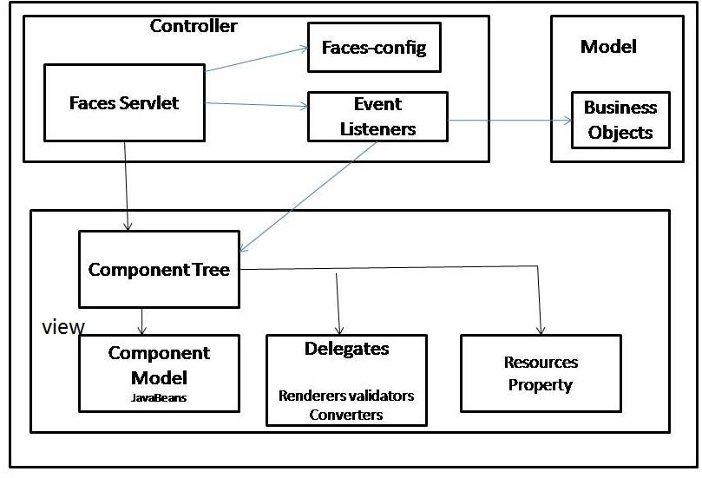

The above figure describes the basic architecture of a JSF Web application. The Framework uses a Component based development where each component is a module containing a set of semantically related components. Java Server Faces uses Enterprise Java Bean for the back-end and xhtml for the front end.

Java Server Faces uses

This application, Sharethoughts, makes use of JSF as the framework. The application allows a user to login and post an opinion on any topic. The user may view other posts, like the post or even comment on the post.

On liking the post, the number of likes on that particular post in reflected. The comments on the post may viewed by clicking the button ‘View comments’.

**Difference between Java Server Faces and Spring MVC**

Spring MVC is a request based framework. However, Java Server Faces is a component based framework. Spring MVC works on request-response model. Java Server Faces work more on events.

Accessing the database using Java Server Faces is tedious. Spring MVC provides a JDBC template that makes the accessing of the database easier. Spring MVC allows to clean up the resources automatically.

Java Server Faces is more of a presentation framework that focuses more on the view such as implementing High level visual building blocks (E.g.: sliders, panels, dialog box). Most of these components provided by the JSF support AJAX. JSF abstracts the implementation of these components. On the other hand, Spring MVC throws more light on the controller and how the requests are mapped.

**BUILD INSTRUCTIONS**

1. Using the command prompt, go to the project folder and run the command **ant init and then** run the command **ant start.**
2. Create the following tables:

**CREATE TABLE BLOG (BLOGID NOT NULL PRIMARY KEY, TITLE VARCHAR(40), DESCRIPTION VARCHAR(1000), BLOGDATE DATE, USERNAME VARCHAR(40), LIKEDCOUNT INT);**

**CREATE TABLE BLOGUSERS (USERID NOT NULL PRIMARY KEY, USERNAME VARCHAR(40), FIRSTNAME(40), LASTNAME VARCHAR(40), PASSWORD VARCHAR(40), EMAIL VARCHAR(40));**

**CREATE TABLE LIKED (BLOGID INT NOT NULL, LIKEDCOUNT INT , LIKEDUSER VARCHAR(40), FOREIGN KEY(BLOGID) REFERENCES BLOG(BLOGID));**

**CREATE TABLE COMMENTS (BLOG INT NOT NULL, COMMENTS VARCHAR(1000), USERNAME VARCHAR(40), FOREIGN KEY(BLOGID) REFERENCES BLOG(BLOGID));**

1. In the project folder run the command **mvn install.**
2. Open the tomcat in manager mode.
3. Deploy the application by selecting the generated WAR file in target folder.

**SCREENSHOTS**

Login page

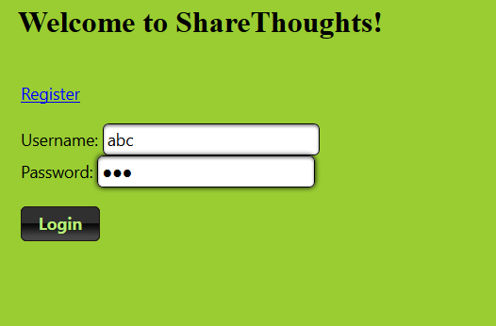

Public Home Page

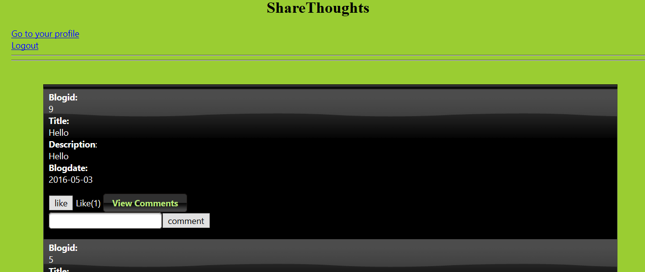

User Home Page

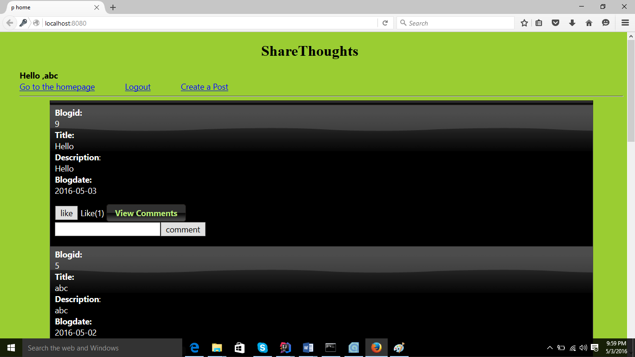

Create Post

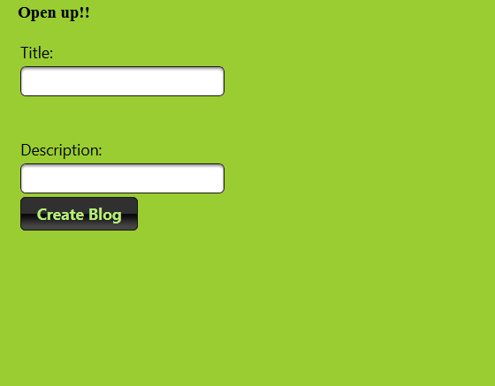

View Comments

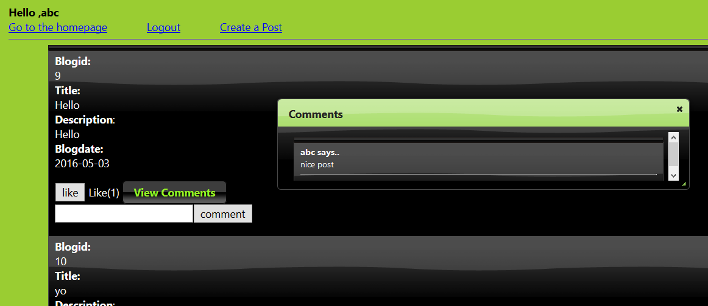

Register Page

